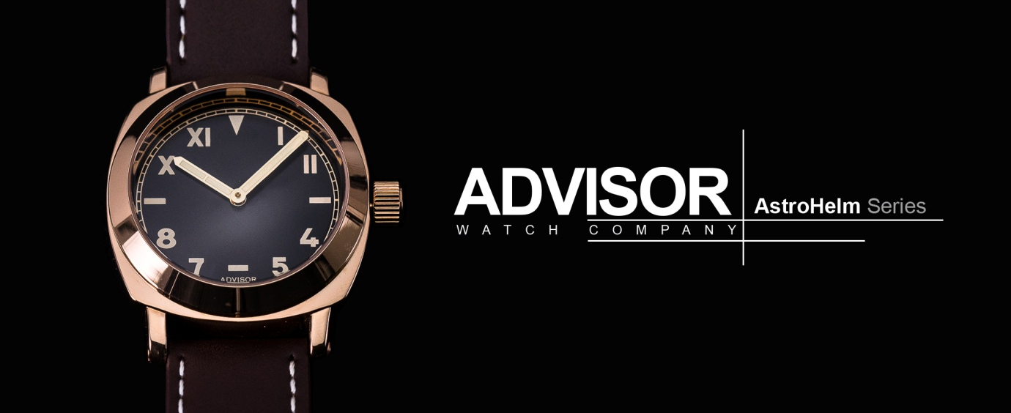
ASTROHELM SERIES - TRIBUTE TO HISTORY
31 July, 2017, team from Advisor Watch Company launched its second model the AstroHelm on Kickstarter, a crowdfunding platform for startup and aspiring brands.

Simplicity is the ultimate sophistication. Advisor AstroHelm series pay tribute to the heritage California dial design first appear in the 1930s. It is a watch dial that consists of half Roman and half Arabic numerals.

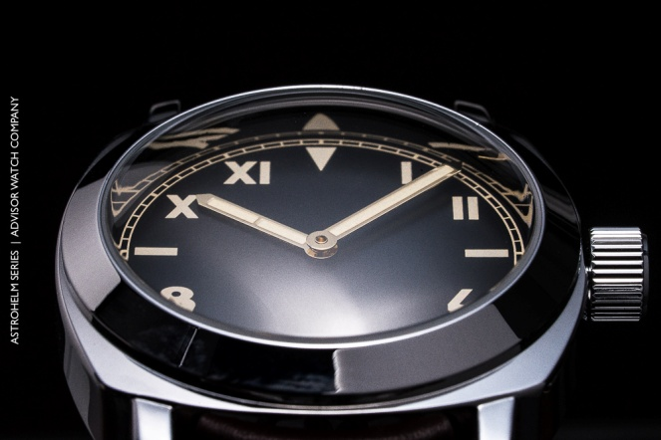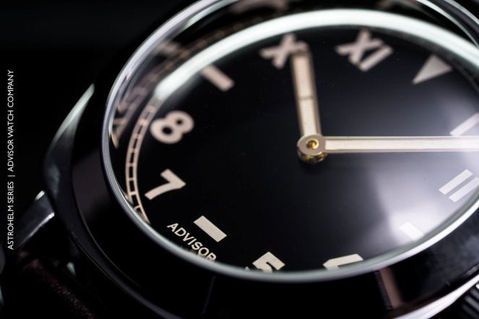
​
The markers and hands are lavishly equipped with luminous colour which, mimics the appearance of aged radium. It uses a highly double domed glass that beautifully brings out the extreme curve to the watch front. History combined with style, the AstroHelm underlining magnificently the vintage character of this watch.

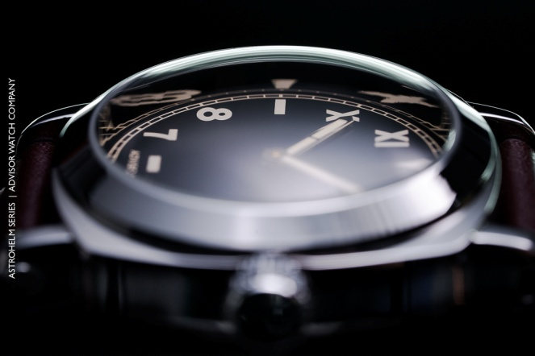
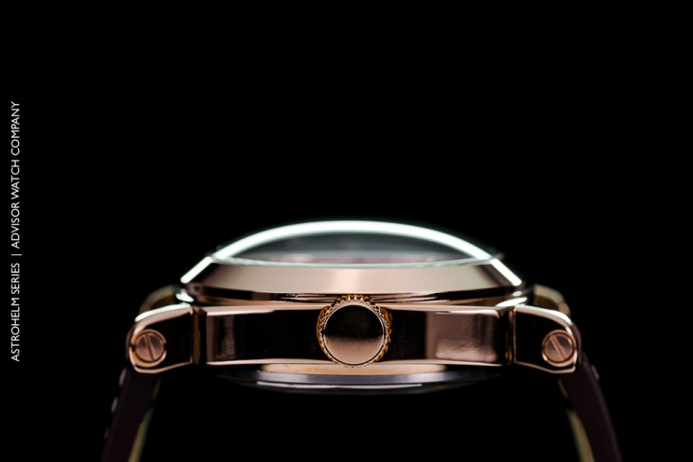

AstroHelm lines up both quartz and automatic limited edition version which caters for different audiences. AstroHelm pushes the limits to boldly installed a high curvy domed resemble an astronaut helmet which brings out the unique aesthetic look of the timepiece from different angles.

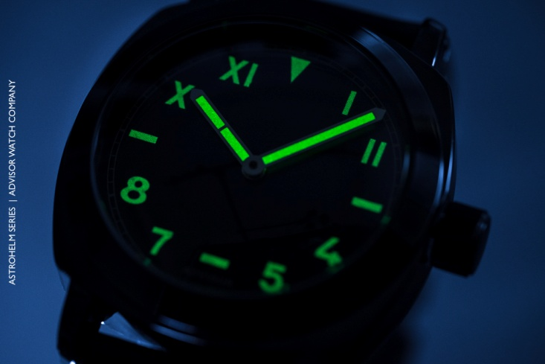

Specification
AstroHelm Quartz | AstroHelm Automatic LE Special Release
- Stainless Steel  - Diameter 44.5 mm  - Height 16 mm  - Lug Width 24 mm  - Double Domed Mineral Glass  - Japan Miyota Quartz  - Water Resistance to 5 ATM  - California Dial Vintage  - Luminous Vintage "Old Radium"  - Hour and Minute with Luminous Vintage "Old Radium"  - 24 mm Full Grain Leather Strap | - Stainless Steel  - Brushed Antique Plating Dial  - Diameter 44 mm  - Height 14 mm  - Lug Width 24 mm  - Double Domed Sapphire Crystal  - Japan NH35 Automatic  - Date Function  - Open Back Case Featuring Movt  - Water Resistance 10 ATM  - California Dial Vintage  - Luminous Vintage "Old Radium"  - Hour and Minute with Luminous Vintage "Old Radium"  - 24 mm Full Grain Leather Strap

For more information on AstroHelm, visit:
https://www.kickstarter.com/projects/1841642015/advisor-astrohelm-watch-tribute-to-history
About Advisor Watches
Advisor Watch Company (AWC) was established with an objective to bring unique and quality timepieces to the market at an affordable price without compromising on the design. Great men have worn watches for hundreds of years. Wearing a watch is not merely for its function or as an accessory only, but it is a man's reflection and connection to the past, defining his style and who he is.

